Topic 1: [Topic 1: git init](#_Topic_1:_git)

[Topic 2: Git Status , Git add , git commit](#_Topic_2:_Git)

[Topic 3: Using git after installation](#_Topic_3:_Using)

[Topic 4: Modify the file and commit it](#_Topic_4:_Modify)

[Topic 5: git log](#_Topic_5:_git)

[Topic 6: git Restore](#_Topic_6:_git)

[Topic 7 : git reset](#_Topic_7_:)

Topic 8 : [git](#_Topic_8_:_1) [Stash](#_Topic_8_:), git Stash pop

[Topic 9 :To add a repository:](#_Topic_8_:To)

[Topic 10 :To add a origin url in your folder](#_Topic_10_:To)

[Topic 11 :To See how many remote URL are associated with folder](#_Topic_10_:To_1)

[Topic 12 :To Push your changes to git hub server](#_Topic_12_:To)

[Topic 13 : Create a new Branch](#_Topic_13_:)

[Topic 13 : Create a new Branch](#_Topic_13_:)

[Topic 14 :Git clone](#_Topic_14_:)

[Topic 15 :Git add upstream url](#_Topic_15_:)

[Topic 16 :Git push](#_Topic_16_:)

[Topic 17 :Git pull](#_Topic_17_:)

[Topic 18 :Git Fetch](#_Topic_18_:)

[Topic 19 : To delete the repositories](#_Topic_14_:_1)

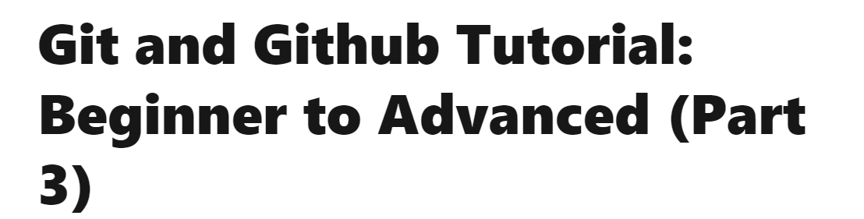

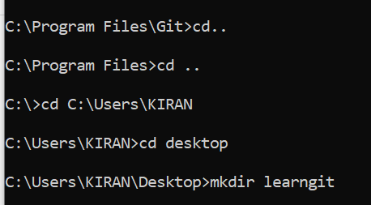

# Topic 1: git init

C:\Users\KIRAN\Desktop\learngit>git init

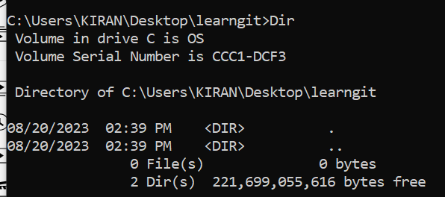

To see hidden files

C:\Users\KIRAN\Desktop\myGit1>dir /A:H

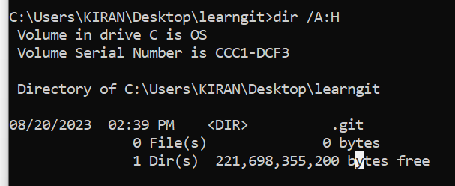

.git folder is created

* C:\Users\KIRAN\Desktop\learngit>dir .git
* 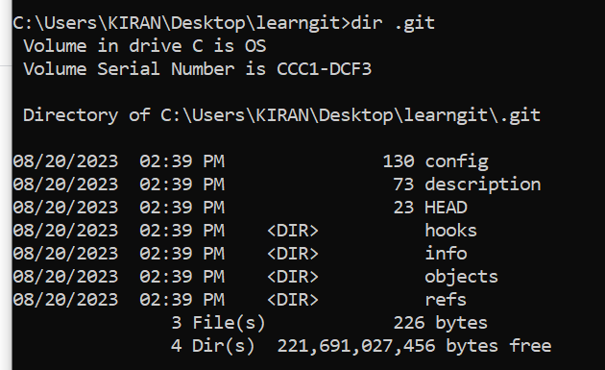

Clear the screen

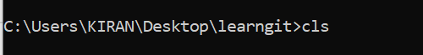

# Topic 2: Git Status , Git add , git commit

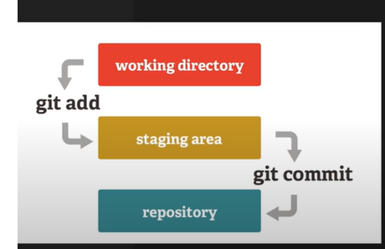

1. Create assignment\_1.txt file

2. git add .

3. git commit –m “ Assignment\_1 file added”

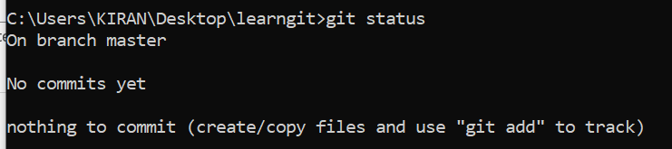

To open a txt file use

* C:\Users\KIRAN\Desktop\learngit>notepad test.txt



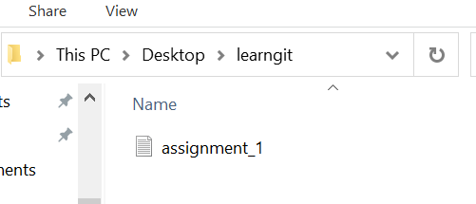

Git status : It will display file created in red color

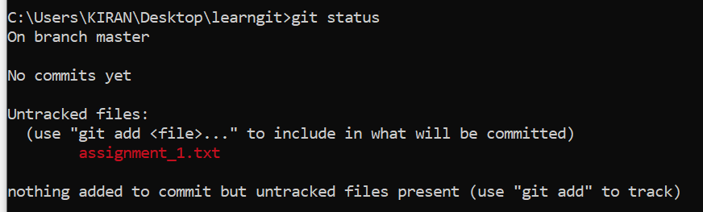C:\Users\KIRAN\Desktop\learngit>git status

(Move to Stage Area)

* C:\Users\KIRAN\Desktop\learngit>git add .
* or
* C:\Users\KIRAN\Desktop\ learngit >git add assignment\_1.txt



(example its like went to stage for Clicking the photo)

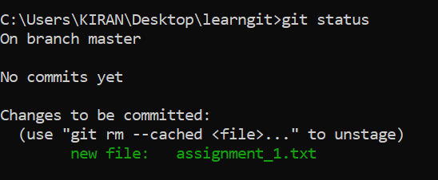

* C:\Users\KIRAN\Desktop\learngit>git commit -m " Assignment\_1.txt Added"
* (example its like Clicking the photo and storing in camera)

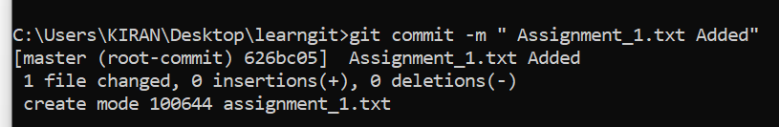

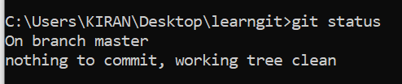

# Topic 3: Using git after installation

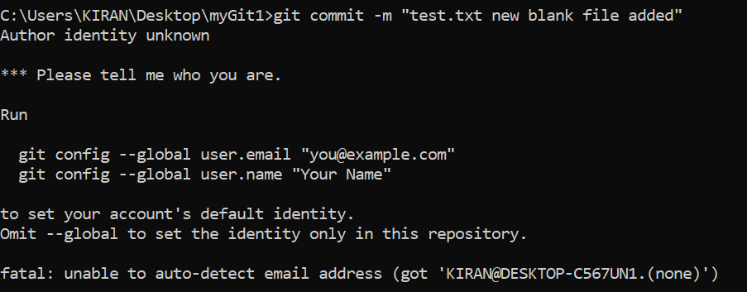

C:\Users\KIRAN\Desktop\myGit1>git config --global user.email "kiranchikdsffhale@gmail.com"

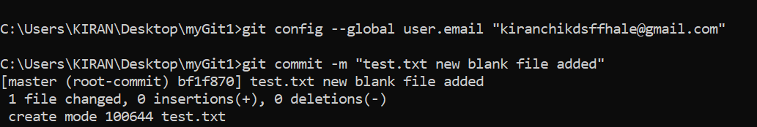

C:\Users\KIRAN\Desktop\myGit1>git config --global user.email "kiranchikhale.2025@gmail.com"

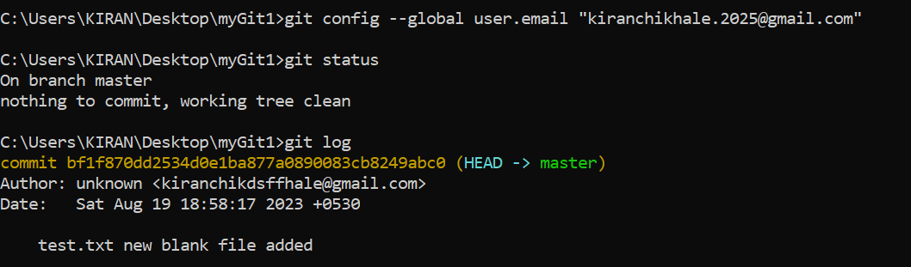

# Topic 4: Modify the file and commit it

1. modify assignment\_1.txt file

2. git add .

3. git commit –m “ Assignment\_1 comment added”

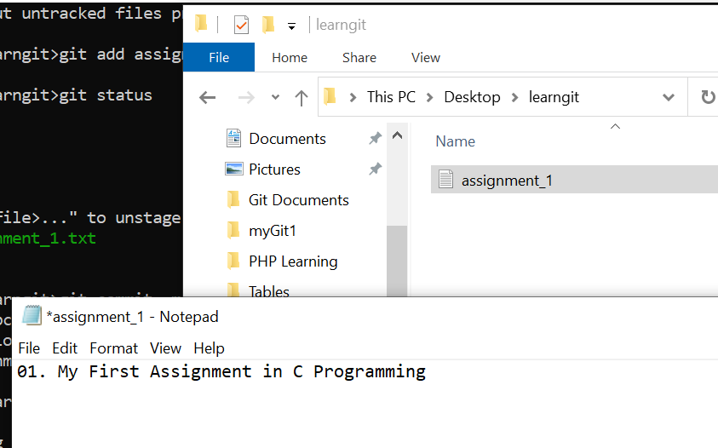

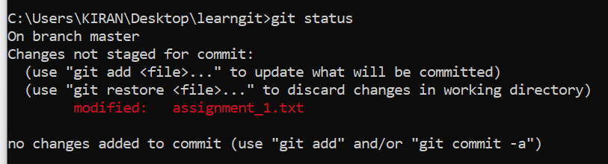

C:\Users\KIRAN\Desktop\learngit>git add assignment\_1.txt



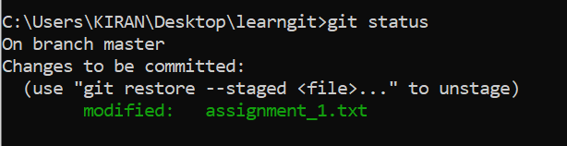

C:\Users\KIRAN\Desktop\learngit>git commit -m "Assignment1.txt modifier , added comment\_1"

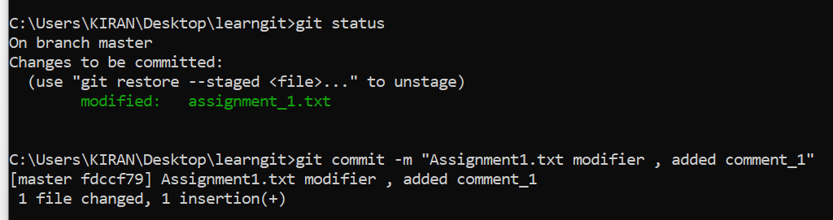

# Topic 5: git log

1. It will show the history of commits

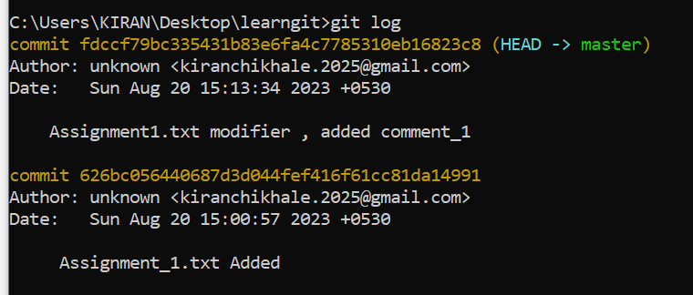

# Topic 6: git Restore

Want to remove from the stage. Basically person is on stage and what we are saying is we don’t want to take your photo we have already taken it

1. Add a new file called assignment\_2.txt
2. Git add .
3. git restore --staged assignment\_2.txt.txt

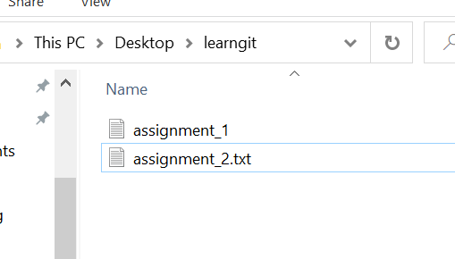

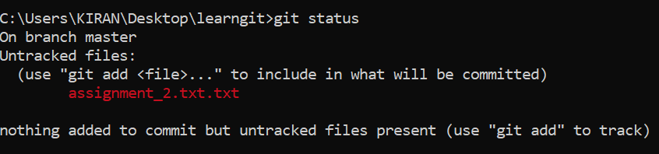



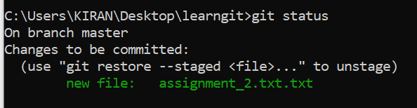

C:\Users\KIRAN\Desktop\learngit>git restore --staged assignment\_2.txt.txt

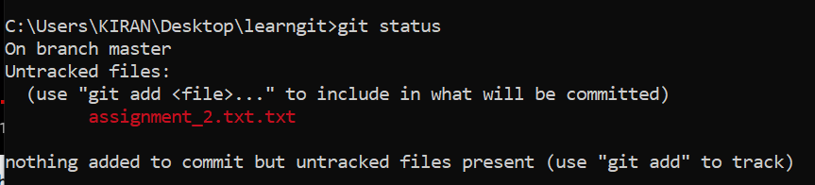

# Topic 7 : git reset

1. we want to remove till particulate commit
2. git add .
3. git commit -m " Assignment.txt.txt file added"
4. git log
5. git reset d20905e530491880ba92d8f1d2b611c3e2220729

C:\Users\KIRAN\Desktop\learngit>git add .



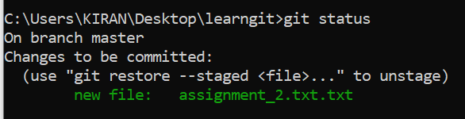

C:\Users\KIRAN\Desktop\learngit>git commit -m " Assignment.txt.txt file added"

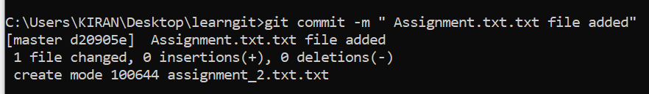

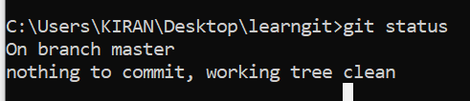

C:\Users\KIRAN\Desktop\learngit>git log

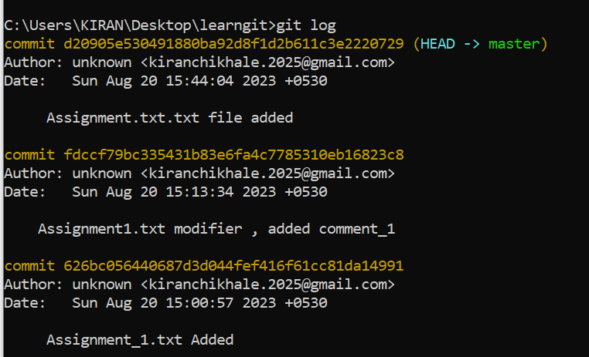

C:\Users\KIRAN\Desktop\learngit>git reset d20905e530491880ba92d8f1d2b611c3e2220729

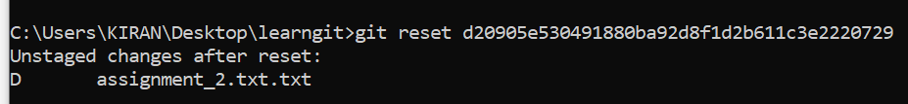

git reset (again)

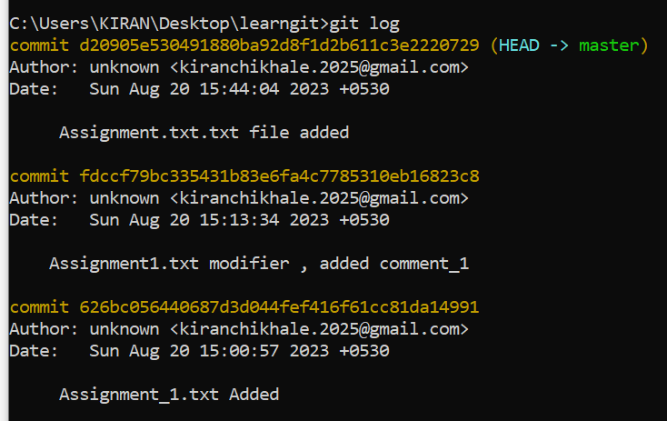

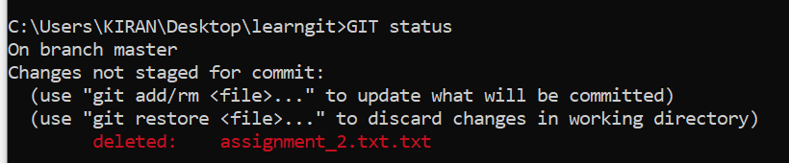

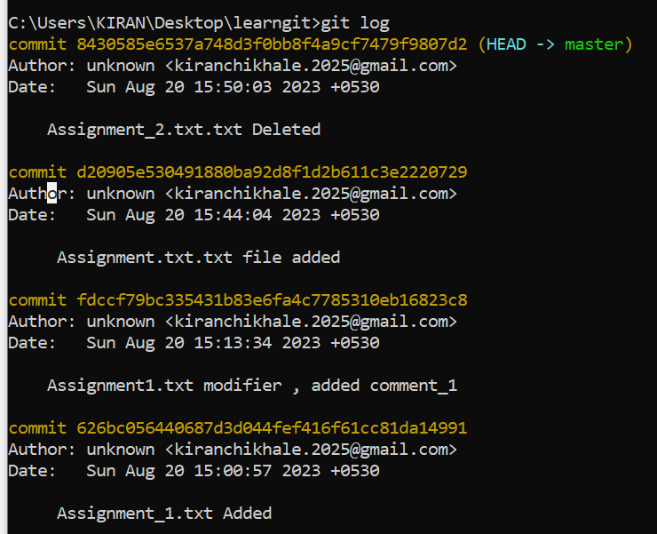

C:\Users\KIRAN\Desktop\learngit>git reset d20905e530491880ba92d8f1d2b611c3e2220729

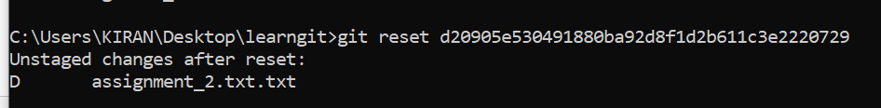

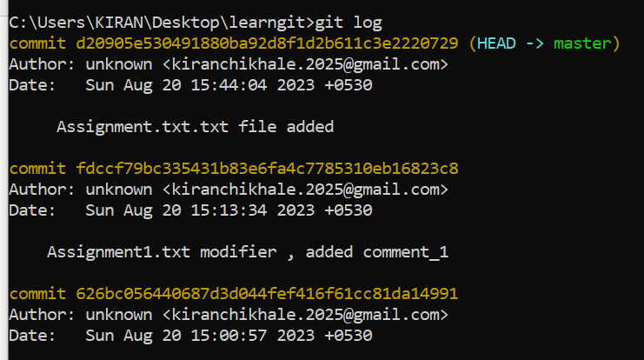

# Topic 8 : git Stash, git Stash pop

I don’t want to lose /delete my changes. You have modified the code and now due to some reason you want to work on clean code base but you don’t want to lose changes you made so you will stash that code.

1. Delete assignment\_2.txt
2. Git add .
3. Add assignment\_3.txt file
4. Git add .
5. Add new file Assignment4.txt
6. git stash
7. git stash pop
8. Git stash clear

C:\Users\KIRAN\Desktop\learngit>del assignment\_2.txt.txt



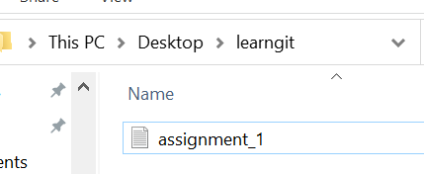

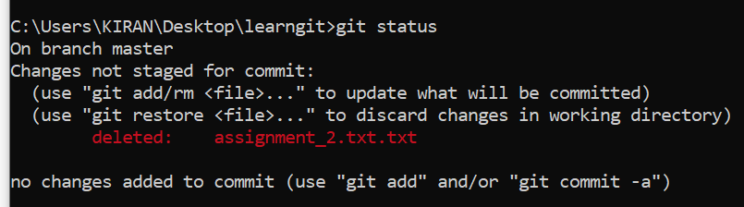

C:\Users\KIRAN\Desktop\learngit>git add .



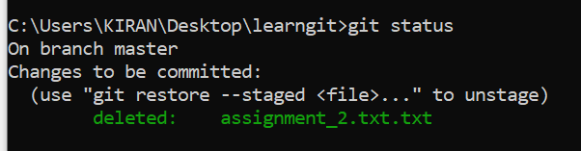

C:\Users\KIRAN\Desktop\learngit>git commit -m "Assignment\_2.txt.txt Deleted"

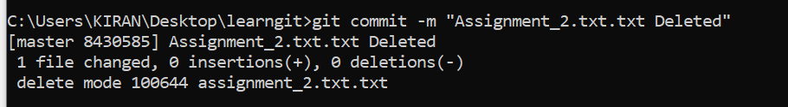

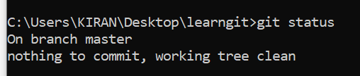

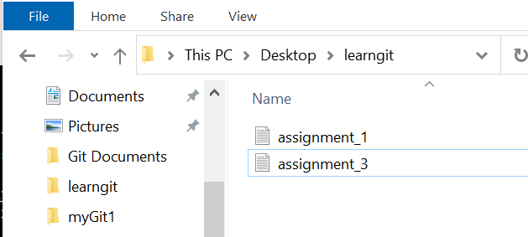

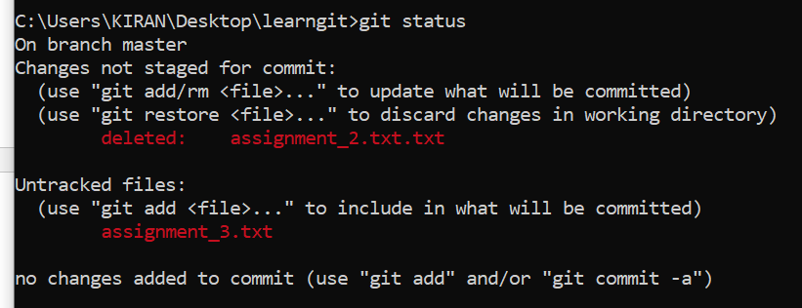



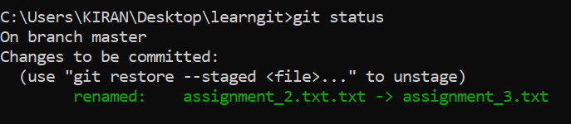

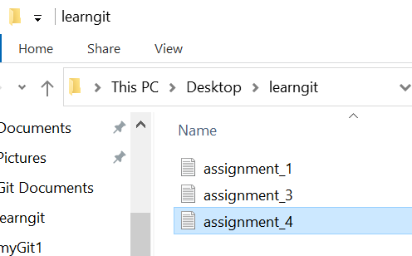

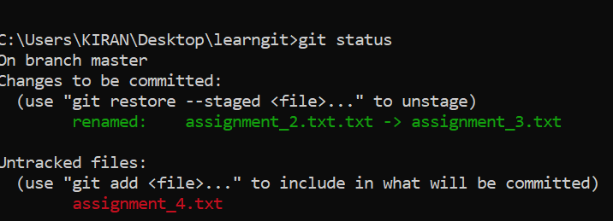



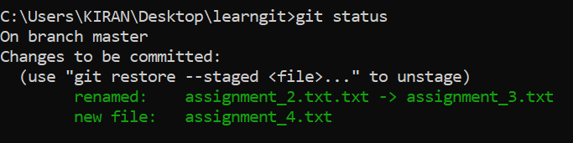

C:\Users\KIRAN\Desktop\learngit>git stash



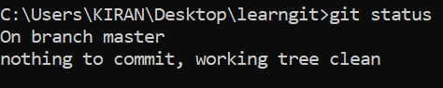

C:\Users\KIRAN\Desktop\learngit>git stash pop

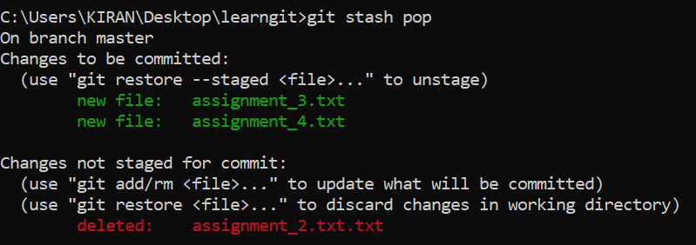

C:\Users\KIRAN\Desktop\learngit>git stash pop

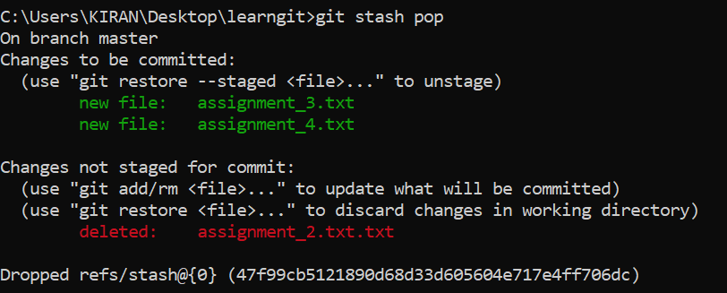

Git stash clear





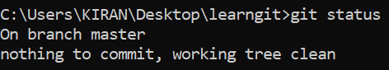

# Topic 9 :To add a repository:

click on new

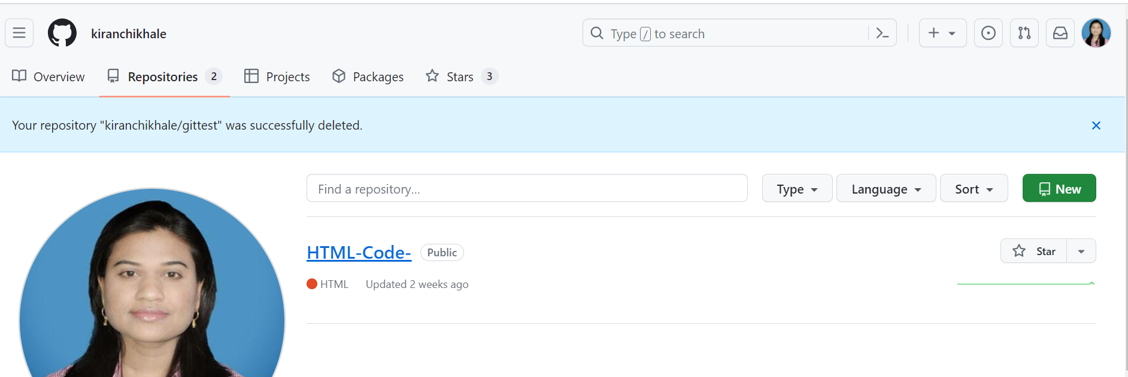

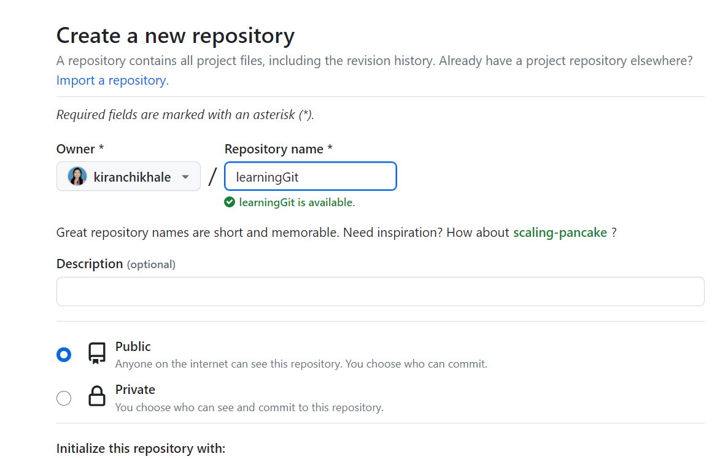

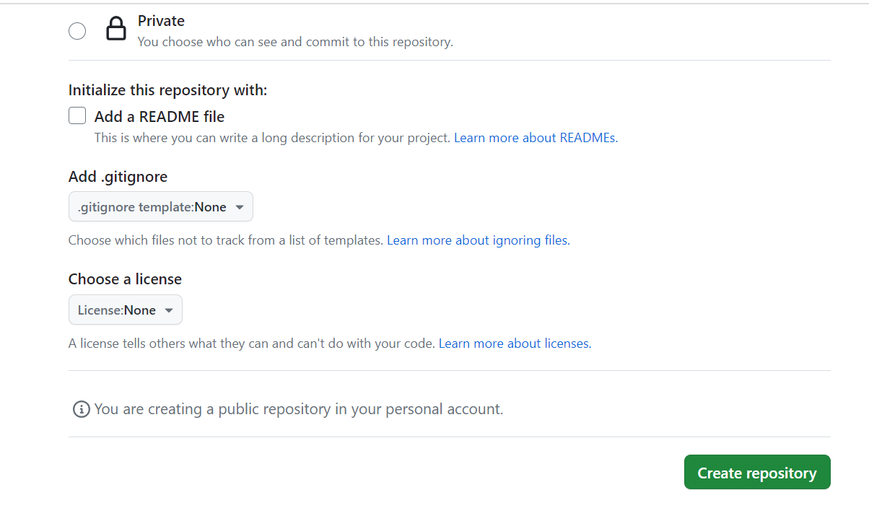

Add a new file to repository

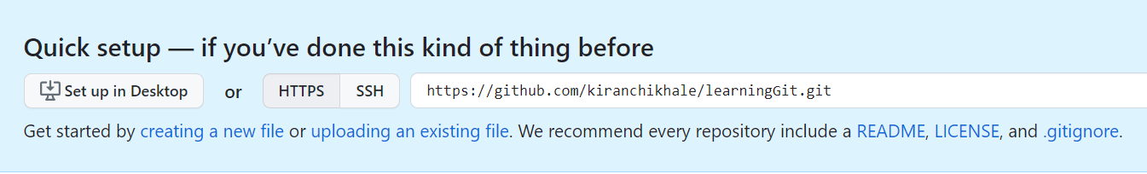

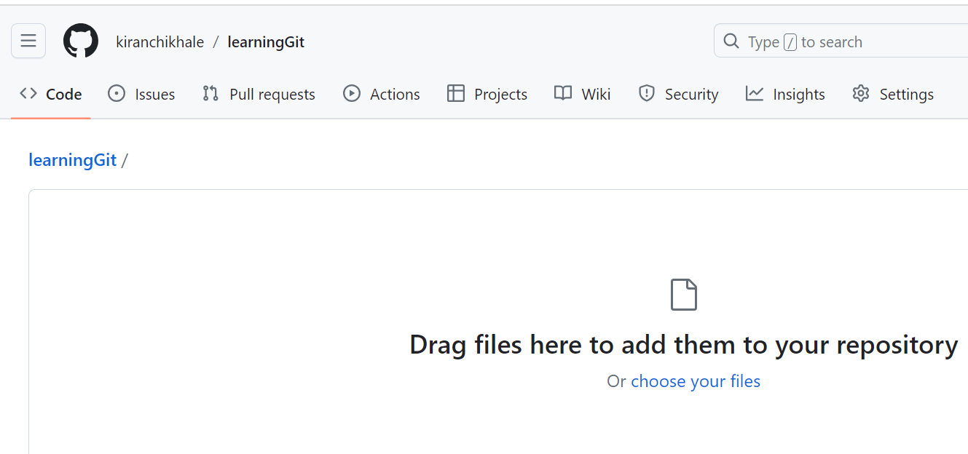

# Topic 10 :To add a origin url in your folder

C:\Users\KIRAN\Desktop\learngit>git remote add myorigin <https://github.com/kiranchikhale/learningGit>



# Topic 11 :To See how many remote URL are associated with folder

C:\Users\KIRAN\Desktop\learngit>git remote -v

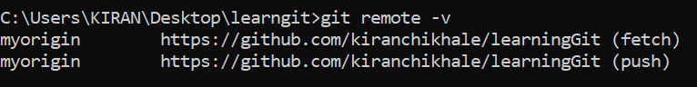

# Topic 12 :To Push your changes to git hub server

C:\Users\KIRAN\Desktop\learngit>git push myorigin master

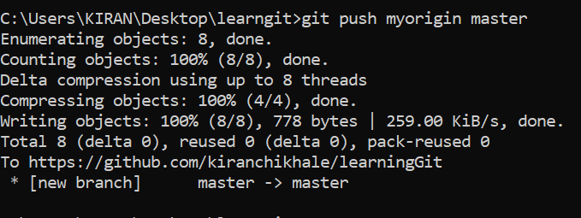

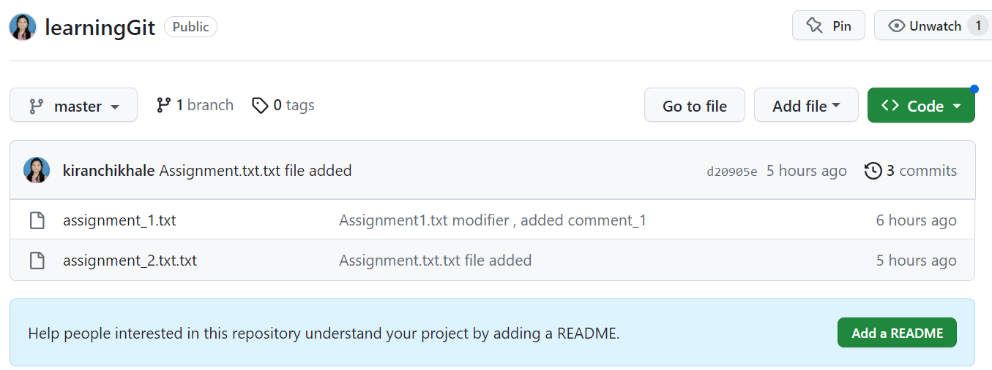

3 commit

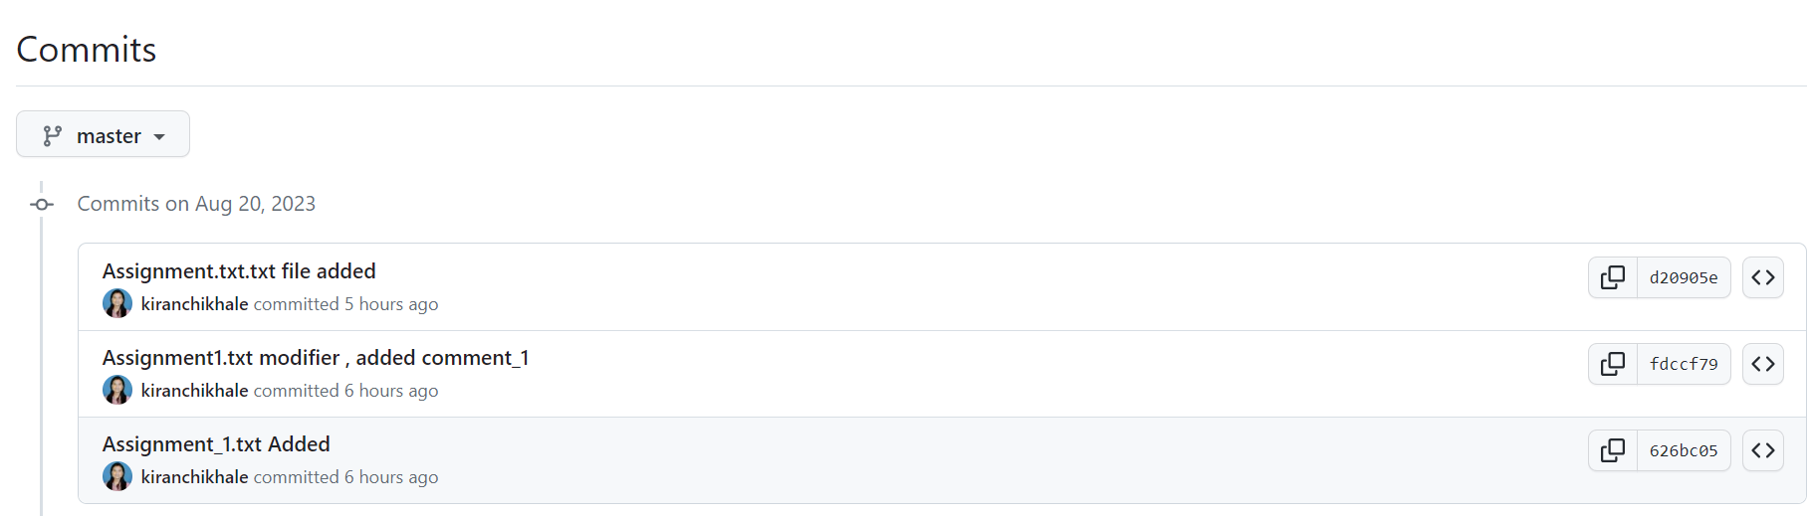

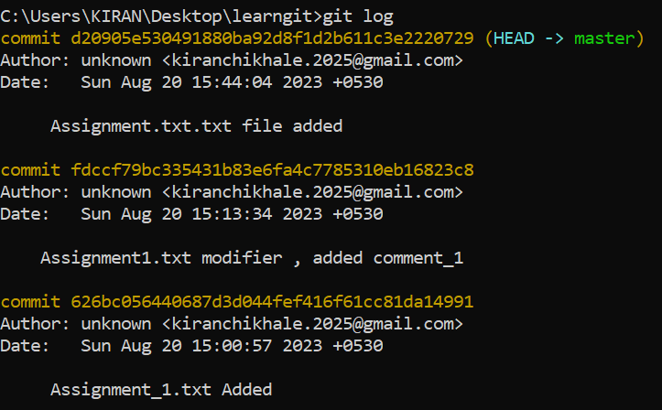

Branching : whenever you want to add any thing to repository always make branch

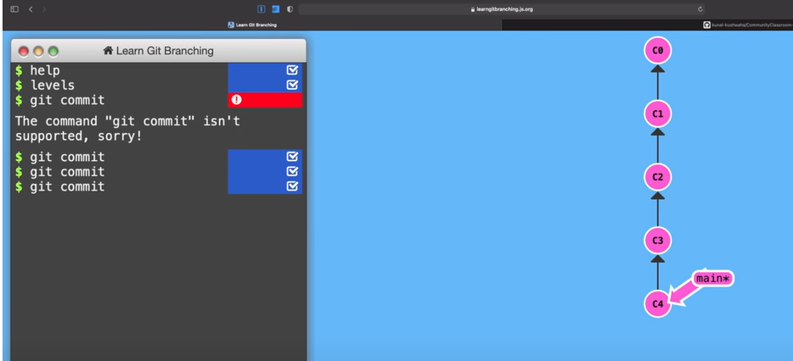

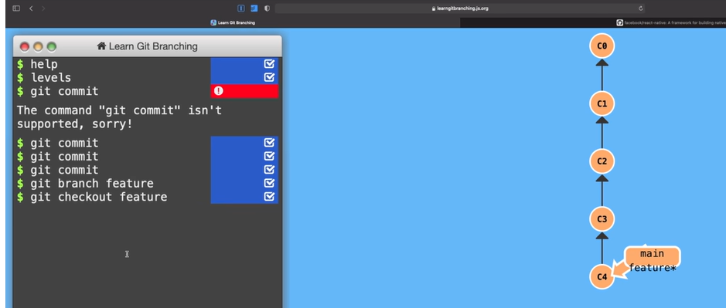

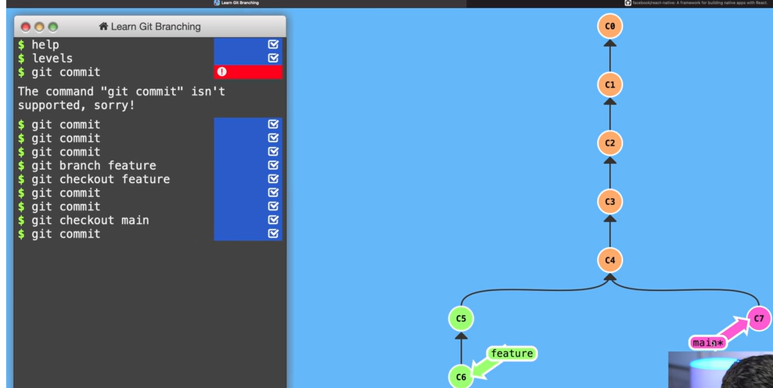

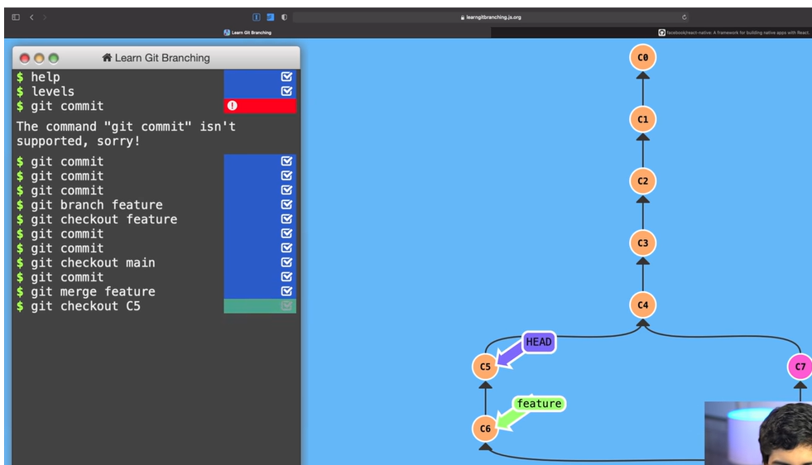

# Topic 13 : Create a new Branch

C:\Users\KIRAN\Desktop\learngit>git branch feature\_1

C:\Users\KIRAN\Desktop\learngit>git checkout feature\_1

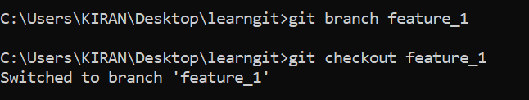

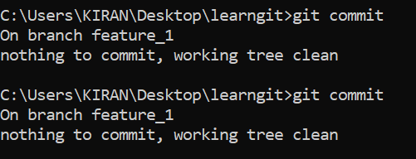

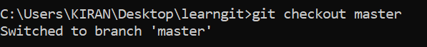

C:\Users\KIRAN\Desktop\learngit>git merge feature\_1

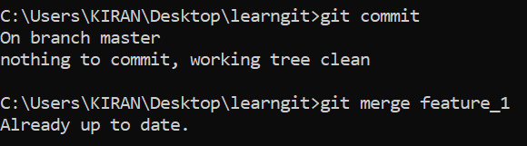

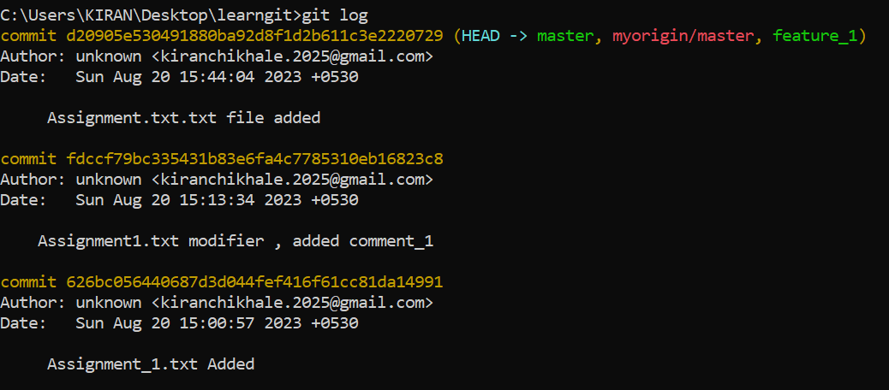

\

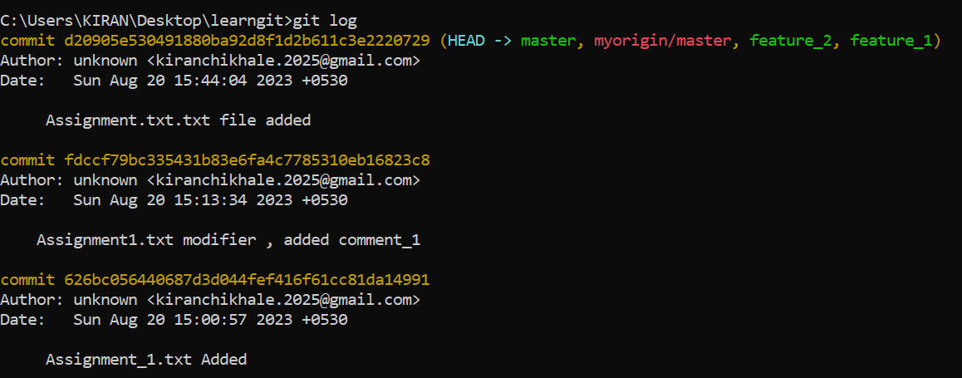

# Topic 14 : Git Clone

Go to git terminal and do

*git clone url*

(it will download the project in your hard disk)

Upstream URL : From where you have forked it

# Topic 15 : Git remote add upstream

This add a url where your code is forked from

*Git remote add myupstream url*

# Topic 16 : Git Push

Your code will get pushed in origin uRL

*Git push myorigin kiran*

# Topic 17 : Git Pull

Pull request is used when you want to add your code in main project where you fetched the code.

*Git pull upstream main*

# Topic 18 : Git Fetch

If you want code from github use

git fetch upstream

# Topic 19 : Git config

git config --global user.name "your name here"

git config --global user.name "Kiran Chikhale"

git config --global user.email "your email id here"

git config --global user.email [kiranchikhale.2025@gmail.com](mailto:kiranchikhale.2025@gmail.com)

git config --global user.name

git config --global user.email

*to edit config settings*

git config -- global --edit

# Topic 19 : To goto any commit

Git chechout [hashcode of that commit/ branch]

Topic 20 : To ignore the file

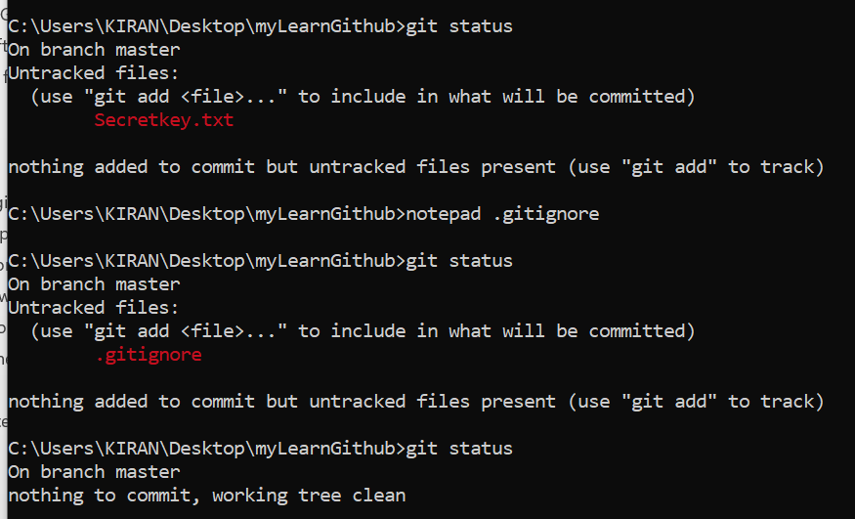

C:\Users\KIRAN\Desktop\myLearnGithub>notepad .gitignore

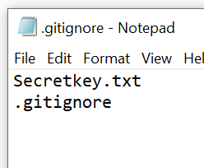

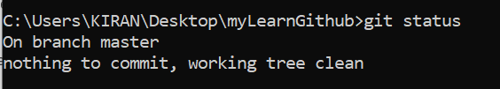

# Topic 20 : To delete the repositories

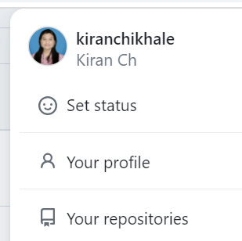

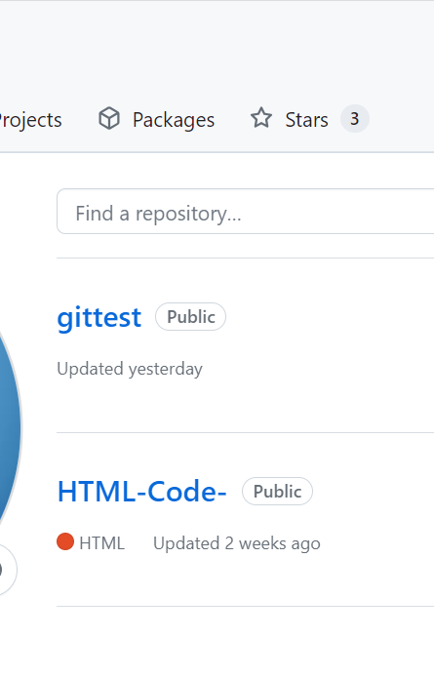

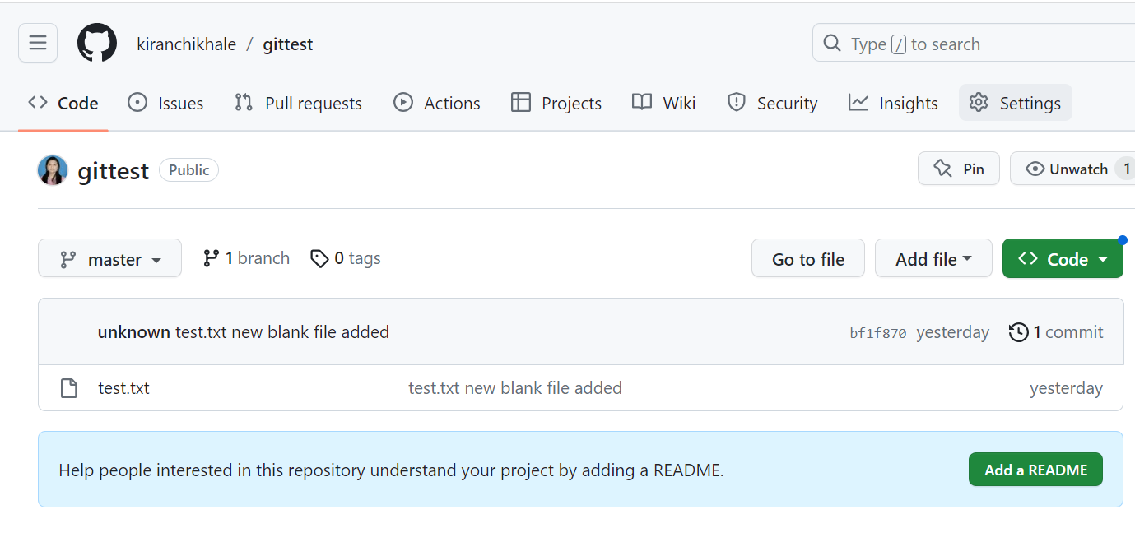

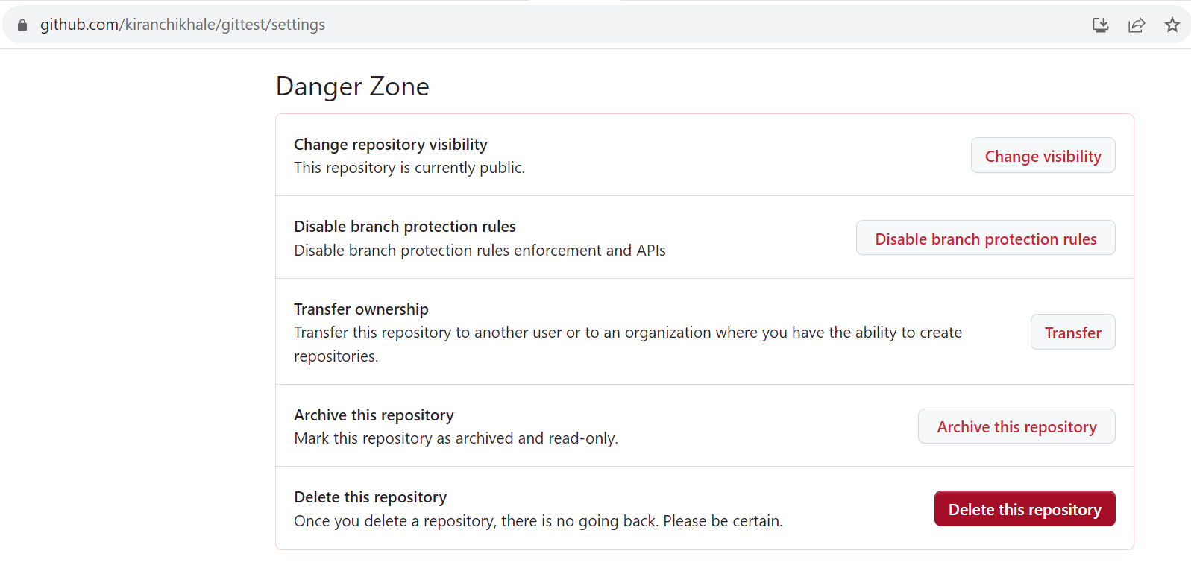

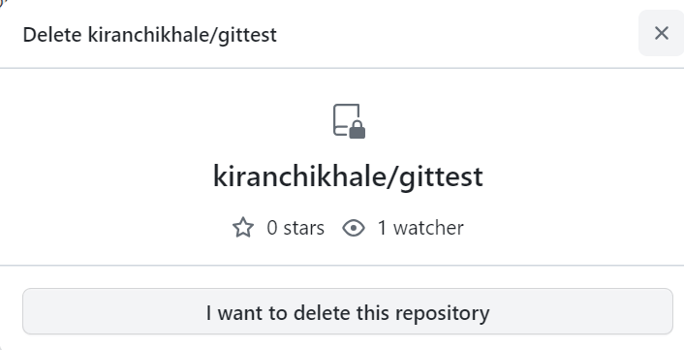

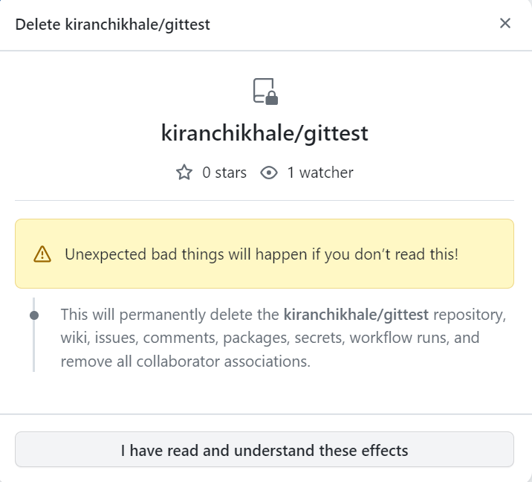

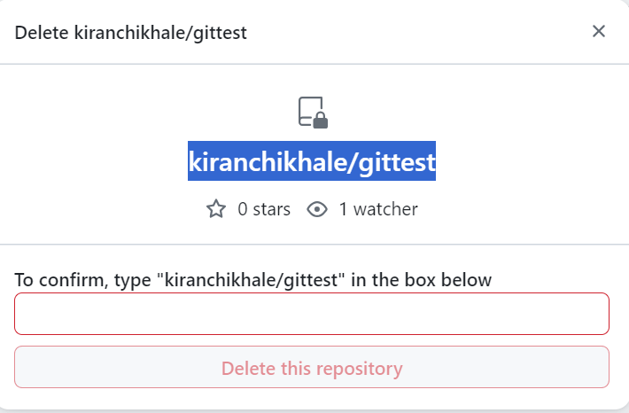

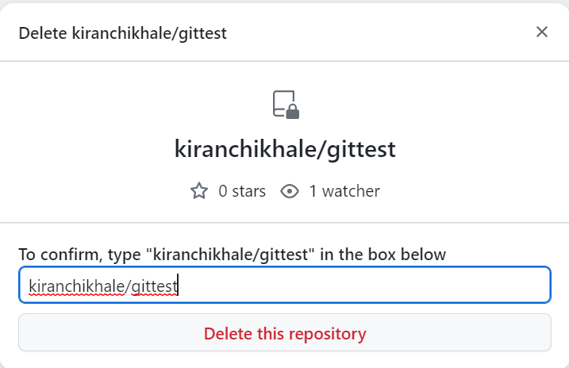

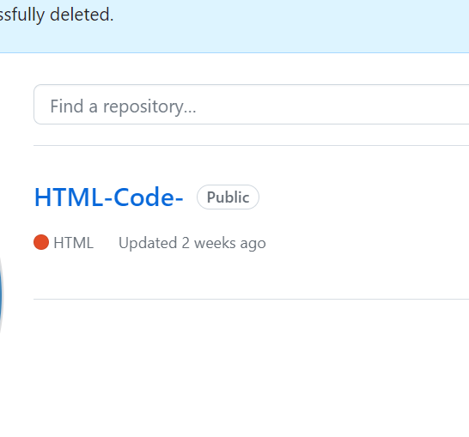

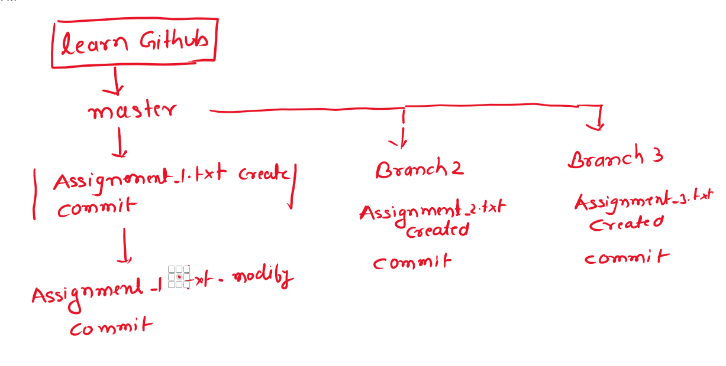

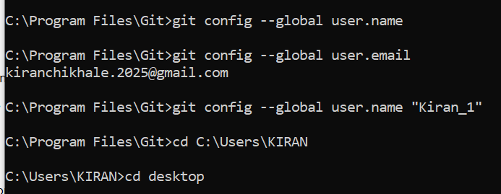

|  |  |  |  |
| --- | --- | --- | --- |
|  |  |  |  |
|  | C:\Users\KIRAN\AppData\Local\Packages\Microsoft.Office.OneNote_8wekyb3d8bbwe\TempState\msohtmlclip\clip_image002.png |  |  |
|  |  | C:\Users\KIRAN\AppData\Local\Packages\Microsoft.Office.OneNote_8wekyb3d8bbwe\TempState\msohtmlclip\clip_image003.png |
|  |  |  |

